Assignment day 4

Account balance exception

using System;

using System.Collections.Generic;

using System.Linq;

using System.Text;

using System.Threading.Tasks;

namespace Assignmentday4

{

class BalException : ApplicationException

{

public BalException(String msg) : base(msg)

{

}

}

class BankAccount

{

private int Account_id;

private string customer_name;

private double bal;

public BankAccount(int Acct_id, string cust_name, double balance)

{

this.Account_id = Acct_id;

this.customer_name = cust_name;

this.bal = balance;

}

public void deposite(double amt)

{

bal = bal + amt;

Console.WriteLine("Transaction Succesful");

}

public void withdraw(double amt)

{

if (bal < 50000)

{

throw new BalException("Transaction Failed, insufficient Balance");

}

else

{

bal = bal - amt;

Console.WriteLine("Tramsaction successfull");

}

}

public void showbalance()

{

Console.WriteLine("Current account balance is " + bal);

}

}

class Bank_info

{

public static void Main()

{

try

{

Console.WriteLine("Enter account no. and customer name");

int Acct_id = Convert.ToInt16(Console.ReadLine());

string cust_name = Console.ReadLine();

BankAccount bankAccount = new BankAccount(Acct_id, cust_name, 0);

operation:

Console.WriteLine(" Press 1 :deposite, Press 2 :withdraw , Press 3 :showbalance, Press 4 : Exit");

int option = Convert.ToInt16(Console.ReadLine());

switch (option)

{

case 1:

Console.WriteLine("Enter the Amount to deposite");

double amt = Convert.ToDouble(Console.ReadLine());

bankAccount.deposite(amt);

goto operation;

case 2:

Console.WriteLine("Enter the Amount to Withdraw");

double amt1 = Convert.ToDouble(Console.ReadLine());

bankAccount.withdraw(amt1);

goto operation;

case 3:

bankAccount.showbalance();

goto operation;

case 4:

Console.WriteLine("thank you; Visit again!");

break;

}

}

catch (BalException b)

{

Console.WriteLine(b.Message);

}

}

}

}

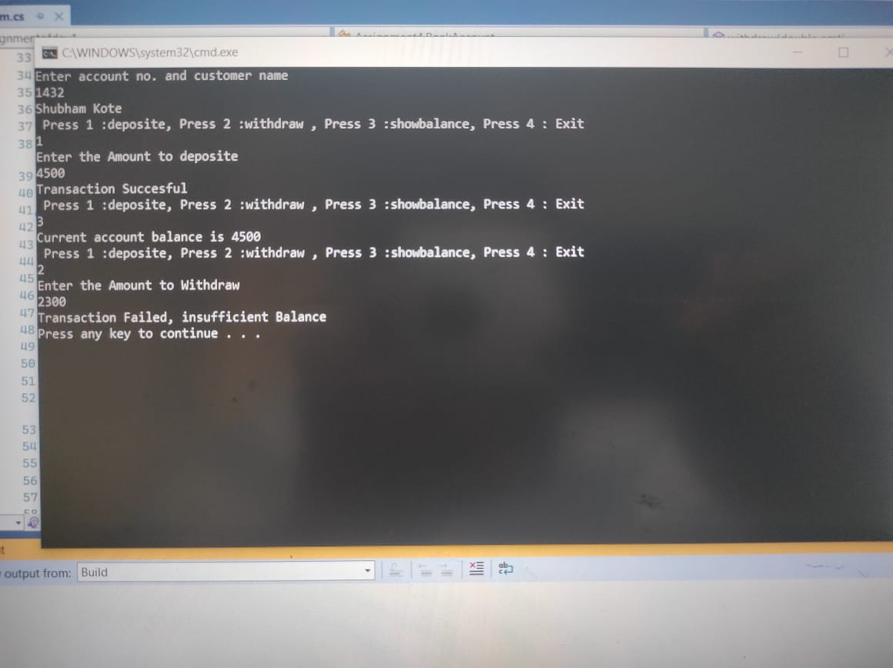

Creating folder and file of student info

using System;

using System.Collections.Generic;

using System.IO;

using System.Linq;

using System.Text;

using System.Threading.Tasks;

namespace Assignment4

{

class DirectoryInfo

{

FileStream fs = null;

String dir;

string filename;

public DirectoryInfo(string dir, string fileName)

{

this.dir = dir;

this.filename = fileName;

}

public void createFile()

{

if (!Directory.Exists(dir))

{

Directory.CreateDirectory(dir);

}

fs = new FileStream(dir + filename + ".txt", FileMode.OpenOrCreate);

Console.WriteLine(filename + "File created succesfully");

}

public void getDirectoryInfo()

{

Console.WriteLine(dir);

}

public void saveToFile(string data)

{

StreamWriter sw = new StreamWriter(fs);

sw.Write(data);

sw.Close();

fs.Close();

Console.WriteLine("Data Save succesfully");

}

public void viewSaveFile()

{

FileStream f2 = new FileStream(dir + filename + ".txt", FileMode.OpenOrCreate);

StreamReader sr = new StreamReader(f2);

string data = sr.ReadToEnd();

Console.Write(data);

}

}

class ProjectManager

{

public static void Main()

{

Console.WriteLine("Enter File name");

String name = Console.ReadLine();

DirectoryInfo fileUtility = new DirectoryInfo(@"D:\Student\", name);

fileUtility.createFile();

Console.WriteLine("please enter youe details");

Console.WriteLine("Your name");

String pname = Console.ReadLine();

Console.WriteLine("Enter your age");

String page = Console.ReadLine();

Console.WriteLine("Enter your city");

String pcity = Console.ReadLine();

Console.WriteLine("Enter your subject");

String psub = Console.ReadLine();

fileUtility.saveToFile("name :" + pname + " " + "subject" + psub + " " + "age:" + " " + page + " " + "city :" + pcity + " " + "subject" + " " + psub);

Option:

Console.WriteLine("Select What You want next");

Console.WriteLine("Press 1 to view Save File");

Console.WriteLine("Press 2 to view Save Info");

Console.WriteLine("Press any key to EXIT");

int userData = Convert.ToInt16(Console.ReadLine());

switch (userData)

{

case 1:

fileUtility.viewSaveFile();

goto Option;

case 2:

fileUtility.getDirectoryInfo();

goto Option;

break;

default:

break;

}

}

}

}

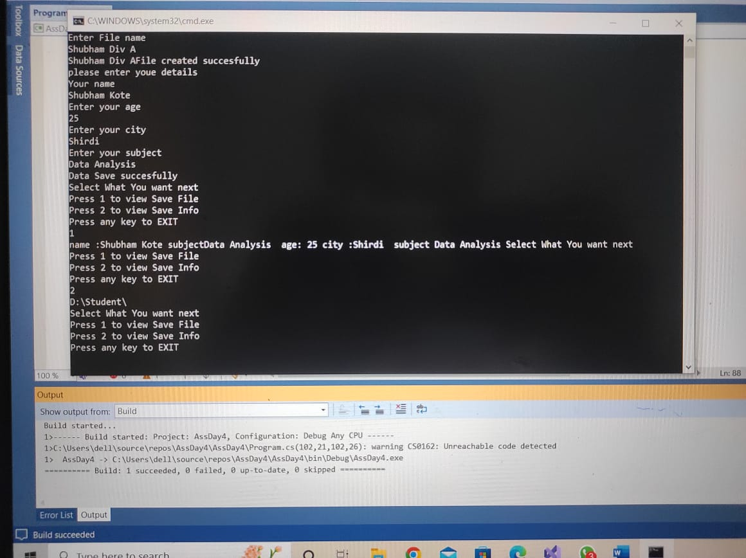

Program to accept person details

using System;

using System.Collections.Generic;

using System.Linq;

using System.Text;

using System.Text.RegularExpressions;

using System.Threading.Tasks;

namespace AssignmentDAy4_3

{

class ProjectDetails

{

public static void Main()

{

Console.WriteLine("enter name ,pid,mob number");

String name = Console.ReadLine();

string pid = Console.ReadLine();

String Mobile_no = Console.ReadLine();

String Pttern1 = @"^[A-za-z]{2,10}$";

Regex ex = new Regex(Pttern1);

Console.WriteLine(ex.IsMatch(name));

String Pttern2 = @"^\d[0-9]{1,5}$";

Regex ex1 = new Regex(Pttern2);

Console.WriteLine(ex1.IsMatch(pid));

String Pttern3 = @"^[0-9]{10}$";

Regex ex2 = new Regex(Pttern3);

Console.WriteLine(ex2.IsMatch(Mobile_no));

}

}

}

